Mantoux Tuberculin skin Test

The Mantoux test or Mendel- Mantoux test (also known screening test, tubercline sensitivity test, pirquet, or PPD test for purified protein derivative).
Definition:
screening tool for tuberculosis (TB).
It is one of the major tuberculin skin tests used around the world, largely replacing multiple-puncture tests.
Guidelines for reading
the Mantoux Tuberculin skin Test

Note: the results of the skin test must be read by a trained health care worker 48to72hours from the time the test was administered.
Supplies :
- Small, plastic, flexible ruler marked in millimeters.
- Ball point pen to mark edges of the induration.
- Alcohol pad to clean off pen marks.
- Mantoux Tuberclin skin test record form.
- Patient education material.
Preparation:
- Verify that the correct patient has returned for TST reading.
- Explain the procedure to the patient.
- Wash hands.
- Make the patient feel at ease with his/her arm in a relaxed position.
IPMMRE

Inspect for site(I)
- Inspect for arm in good light and on a firm surface.
- Locate the site of injection on the palm –side up surface of the patient's arm supported and slightly flexed at the elbow.
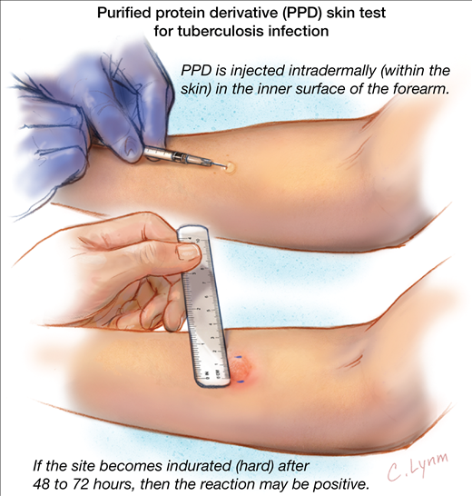

Palpate(P)
- Keep your fingernails short enough so they do not extend beyond the fingertip.
- Since the induration is not always visible, you must rely on palpation with your finger tips to determine induration at the injection site.
- Touch the area lightly with the pads of your fingertips.
- Lightly sweep your fingertips in2-inch diameters from the injection site in all four directions to locate the edges of the induration.
- Use a zig-zag feather-like touch to palpate the area for margins of induration .be careful not to confuse a margin of induration with a margin of muscle on the forearm.to check this, repeat the palpation with the patient's arm raised to a 45-degree angle.

Mark(M)
- Hold your palm over the injection site with your fingertips at the outer edge of the patient's forearm.
- Without lifting move your fingertips from the outer edge toward the induration.
- Rest one fingertips firmly against the induration margin on one side before marking the margin, the fingertips should remain in contact with the skin at all times.
- Use a ball point pen to mark lightly with a fine dot at the widest edge of the induration.
- Repeat the procedure from the other side of the patient's forearm and place the second mark on the margin of induration.
- Palpate again, repeating finger movement toward the injection site to ensure that the induration was marked correctly and adjust the dots, if necessary.
- If the margins are not equally clear all the way around the induration, it is still necessary to mark the margins on each side of the induration .for irregular margins of induration, mark and measure the longest diameter across the forearm.

Measure(M)
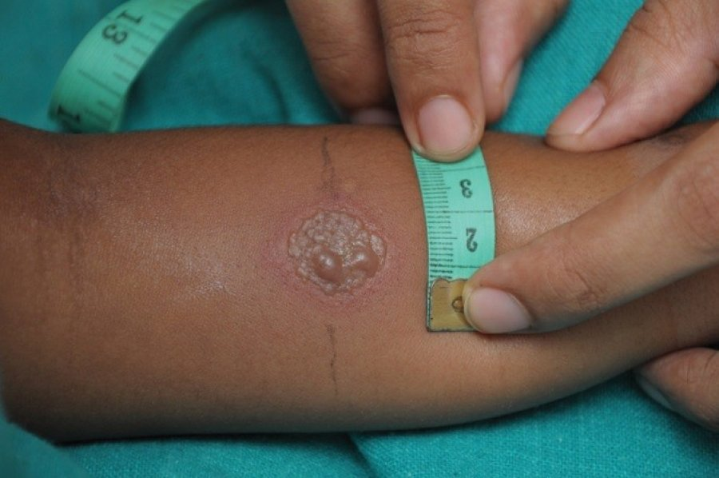
- Measure only the area of induration, a hard, dense, raised formation .
- Do not measure erythema, Redding of the skin that can also have swelling.
- Use the millimeter ruler to measure the diameter of the induration perpendicular to the long axis of the forearm.
- Place the zero ruler line inside the left dot edge and read the ruler line inside the right dot edge.
- If the measurement falls between the two divisions on the millimeter scale, record the lower mark .if unsure, ask a co-worker.
Note:
Reactions to the tuberculin skin test at the injection site will vary .if there is blistering palpate the induration gently as it may be painful .measure only the induration .only the margins of the induration are significant, redness and swelling should not be measured.
Record(R)
- Record the exact measurement in millimeters of induration on the Mantoux tuberculin skin test form .do not record the interpretation of the results as positive or negative.
- Record the date and time the test was read ,the name and signature of the person who read the skin test ,and the presence or absence of adverse effects(blistering, redness, and swelling).
- If there is no induration, this measurement should be recorded as 0 mm of induration.
- Become familiar with the interpretation guidelines for your facility.
Educate(E)
- Explain the significance of a positive skin test .for example, a positive skin test result means latent infection with the TB germ. A negative skin test result means there is no TB infection.
- Direct the patient for follow-up (chest x-ray, if skin test result is positive), if necessary.
- Answer the patient's questions.
- Provide culturally and linguistically appropriate educational materials and documentation to patient.

Classification of TST Reactions

Whether a reaction to the Mantoux tuberculin skin is classified as positive depends on the size induration and the person's risk factors for TB.
≥5 mm of induration is considered a positive reaction in

:

- HIV infected persons.
- Close contacts of a person with infectious TB.
- Persons who have chest x-ray findings consistent with prior TB.
- Organ transplant recipients.
- Persons who are immunosuppressed for other reasons(taking the equivalent of ≥15 mg/day of prednisone for 1month or more.
≥10 mm of induration is considered a positive reaction in:

- Recent immigrants (within last 5 years) from a high –prevalence country.
- Injection drug users (with unknown or HIV negative status).
- Residents or employees of high risk congregate settings (for example, nursing homes or correctional facilities)
- Myobacteriology laboratory personnel.
- Children<4years of age, or children or adolescents exposed to adults at high risk.
- People with other high-risk conditions such as diabetes.
≥15mm of induration is considered a positive reaction

.
- Persons with no known risk factors for TB.
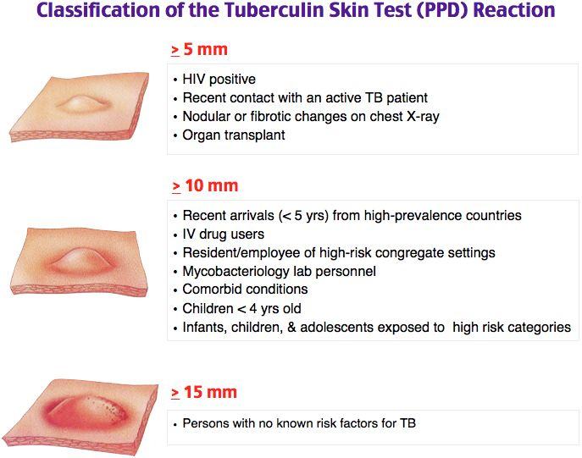
False –negative reactions

Some people have a negative reaction to the tuberculin skin test even though they have LTBI.
These are called false-negative reaction may be due to:
- Anergy(inability to mount an immune response)
- Recent TB infection (within the past 10weeks).
- Very young age (younger than 6 months old).
The most common cause of false-negative reaction is anergy, the inability to react to the skin test because of

1-weakened immune system .
2-while HIV infection is a main cause of anergy.
3-Many conditions, such as Immunosuppressive therapy.
4- severe TB disease itself.
5-recent TB infection(infection within the past 10 weeks).it takes 2to 10weeks after TB infection for the body's immune system to be able to react to tuberculin.

Therefore ,after TB has been transmitted, it takes 2to10 weeks before TB infection can be detected by the tuberculin skin test ,for this reason, close contacts of someone with infectious TB disease with a negative reaction to the tuberculin skin test should be retested 8-10weeks after the last time they were in contact with the person who has TB disease.

6-Very young age. Children younger than 6 months old, may have a false –negative reaction may also occur when the tuberculin skin test is given incorrectly or the results are not measured properly.

