**Intended Learning Objectives (ILOs)**

* Classify tumours of the kidney and give an account of renal cell carcinoma with emphasis of presenting features and morphological appearances.
* Define Wilm’s tumour of the kidney, describe its pathological features and routs of spread.
* Classify tumors of the urinary bladder.
* List the common causes of acute and chronic renal failure.
* Define haematurea and enumerate its causes.
* Define proteinurea and enumerate its causes.
* Define pyurea and enumerate its causes.
* List causes of small sized kidney.
* List causes of kidney enlargement.

**Tumours of urinary tract**

**Tumours of the kidney**

**I. Primary Tumours of the Kidney:**   
 **A. Benign Tumours:**   
 (1) ***Epithelial:*** Cortical adenoma and oncocytoma.   
 (2) ***Mesodermal:*** Medullary fibroma, **angiomyolipoma**, lipoma, leiomyoma,   
 myxoma, haemangioma and lymphangioma.   
 **B. Malignant Tumours:** (1) ***Epithelial:*** Renal cell carcinoma (hypernephroma).   
 (2) ***Mesodermal:*** Sarcomas, malignant lymphomas and multiple myeloma.   
 (3) ***Wilm’s tumour*** (nephroblastoma).   
 **C. Tumours of the Renal Pelvis:   
 (1) *Benign:*** (a) Haemangioma: either capillary or cavernous. Its rupture causes severe   
 haematuria.   
 (b) Papilloma, inverted papilloma, and neurofibroma.   
 **(2)** ***Malignant:*** (a) Transitional cell carcinoma.   
 (b) Squamous cell carcinoma.   
**II. Secondary Tumours of the Kidney:** (1) Direct or lymphatic spread from the adrenal, pancreas and large intestine.   
 (2) Blood stream metastases.

**Adenoma of the Kidney (Cortical Adenoma):**   
- The tumour arises from the cortex. - It appears as a small, rounded yellowish tumour measuring 0.5-2 cm in diameter.   
- The tumour is non- capsulated.   
- Malignant transformation may occur.

**Renal Oncocytoma:**- Encapsulated tumour arising from the collecting ducts.   
- Cut surface is homogenous tan or mahogany brown.   
- Microscopically the cells are large with eosinophilic cytoplasm and small rounded   
 benign-appearing nuclei. The cells are arranged in pseudo-alveolar pattern.

* **Renal Cell Carcinoma (Hypernephroma):   
  -** The most common primary tumor of the kidney in the adult population, accounting   
   for ~80% of kidney tumors - Origin: arises from the tubular epithelium, most often in the proximal convoluted   
   tubules or from a cortical adenoma.

- The tumour is more common in males.   
 - Age: occurs between 60-70 years.

**Gross Picture:** The tumour usually starts at one pole of the kidney and forms a variable sized rounded sharply demarcated mass. Cut surface of the tumour has a characteristic yellow colour due to high lipid content of the tumour cells and shows areas of haemorrhages, necrosis and cystic degeneration.

**Microscopic Picture:** (1) ***Clear cell type* (80%)*:*** This is the commonest type, Both familial and sporadic   
 forms are commonly associated with an underlying genetic defect in the *VHL* (von   
 Hipple Lindu) gene (a tumor suppressor gene on chromosome 3).

The tumors are made up of cells with clear or granular cytoplasm, the cells are large rounded or polyhydral and arranged in acini or trabeculae separated by scanty strom containing thin walled vessels. The cytoplasm is clear or vacuolated due to its high content of lipids and glycogen and the nucleus is small and darkly stained.

(2) ***Papillary type (15%):*** have a papillary growth patternand affect the proximal tubules. The cells are columnar in shape.

(3) ***Chromophobe cell type (5%):*** composed of cells with prominent cell membranes

and pale eosinophilic cytoplasm, usually with a halo around the nucleus.

(4) ***Sarcomatoid type:*** The cells are undifferentiated and spindle shaped.

**Presentation**

The classic **triad of clinical symptoms** includes:

■ Painless hematuria (microscopic or macroscopic).

■ Palpable flank mass.

■ Flank pain.

**Diagnosis**

Renal **ultrasound** shows the presence of a mass. **CT** can provide precise information

on the size and location of the tumor, as well as detect enlarged lymph nodes and

metastases. The most common appearance of clear-cell renal carcinoma is an upper

pole mass with cysts and hemorrhage.

**Spread:** (1) Direct spread: To the renal pelvis, renal capsule, surrounding structures,   
 renal vein and inferior vena cava.   
 (2) Blood spread: Early to the lungs, bones and liver, invasion of left renal vein   
 can cause **left-sided varicocele** due to blockage of left spermatic vein drainage.

(3) Lymphatic spread: To the para-aortic lymph nodes.

**Clinical Effects:**    
 (1) Painless haematuria.   
 (2) Pain in the loin.   
 (3) Palpable mass.   
 (4) Obstruction of the spermatic veins by the tumour produces varicocele.   
 (5) Manifestations due to metastasis in lungs and bone.   
 (6) Anaemia, fever and weight loss.   
 (7) Polycythemia due to secretion of an erythropoietic stimulating substance.  
 (8) Hypercalcemia as a result of production of parathormone-like substance.   
 (9) Gynecomastia as a result of gonadotropin and placental lactogen production.

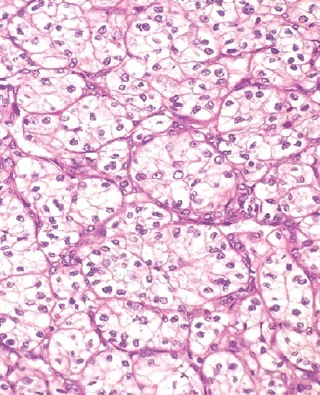 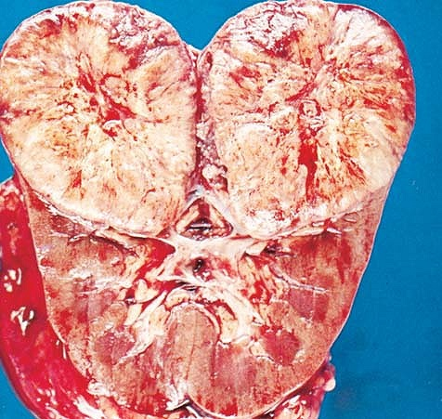

**Wilm’s Tumour (Nephroblastoma or Embryoma): A childhood tumour**- Origin: derived from the renal blastema due to **loss of *WT1*** (a tumor suppressor gene   
 on chromosome 11).   
- Age: The peak incidence is 2-4 years.   
- The tumour constitutes 20% of malignant tumours of children.   
- Bilaterality: bilateral in ***5- 10%*** of cases.

**Presentation:**

- Large, palpable abdominal mass that may extend into the pelvis. - Some patients have hypertension due to excessive renin secretion.

**Gross Picture:** Large rounded or lobulated well circumscribed and soft in   
 consistency. Cut section is pale gray and shows areas of cystic changes, necrosis and   
 haemorrhages.

**Microscopic Picture:** The tumour consists of three components:   
 (1) Cellular nests and sheets of primitive blastemal cells, round to oval with scanty   
 cytoplasm.   
 (2) Mesenchymal component of fibrous tissue, smooth muscle, striated muscle, bone   
 and cartilage.   
 (3) Epithelial component of embryonic tubules and glomeruloid structures.

**Spread:** (1) Local infiltration of the kidney capsule and surrounding structures.   
 (2) Blood spread early to the lung, liver, bone and brainy   
 (3) Lymphatic spread to the para-aortic lymph nodes.

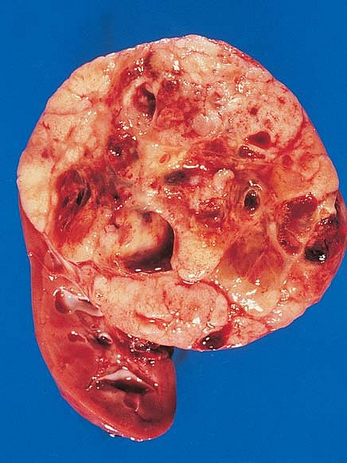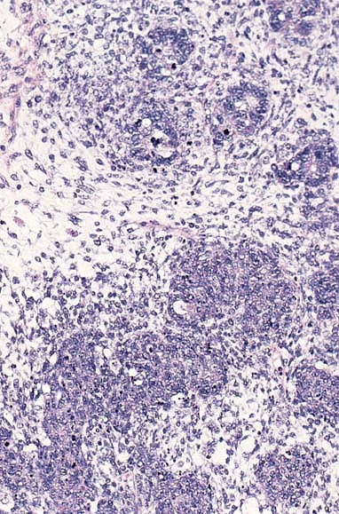

**Causes of enlargement of the Kidney:**

1. **Marked enlargement:**

1- Polycystic kidney.

2- Hydronephrosis

3- Hypernephroma & embryoma**.**

1. **Mild & moderate enlargement:**

1- Inflammations: ADPGN, RGN, early MGN, acute

pyelonephritis & acute interstitial nephritis.

2- Degenerations: cloudy swelling, fatty change & amyloidosis.

3- Circulatory disturbances: CVC & renal vein obstruction.

4- Tumours: primary & secondary tumours.

5- Compensatory hypertophy.

**Causes of small sized kidney:**

1- Congenital hypoplasia.

2- Renal atrophy.

3- Chronic diffuse GN.

4- Chronic Pyelonephritis.

5- Benign nephrosclerosis.

6- Healed multiple renal infarcts.

7- Radiation nephritis.

**Tumours of Urinary Bladder**

**Benign Malignant**

**Epithelial**  **Mesenchymal** **Epithelial** **Mesenchymal**

-Villous pap. - fibroma - T.C.C Rhabdomyosarcoma

-Inverted pap. - leiomyoma - Sq. C.C (Botryoid sarcoma)

-rhabdomyoma - Adenocarc.

-myxoma - Anaplastic carc.

- angioma

**Benign Epithelial Tumours:**

**(1) Transitional Cell Papilloma (Villous Papilloma):**

- Site: arise anywhere within the bladder, most arise from the lateral or

posterior walls at the bladder base.

- Grossly: small, (0.5 to 2 cm), single, pedunculated, reddish grey in colour,   
 friable in consistency, has multiple branching villous like projections.

- Usually recurs after removal & is considered potentially malignant.

- Considered by some as grade I carc., but epithelial layers are 7or less.

- Microscopically: Delicate branching vascular fibrous cores covered by epithelium that   
 is histologically identical to normal urothelium. - Complications: Malignant transformation, Hge, obstruction of the ureteric or   
 urethral openings.

**(2) Inverted papilloma:**

- A benign epithelial tumour.

- Commonly seen in adults & elderly males.

- Usually solitary and presents with haematuria.

- Grossly: Polypoid lesion with smooth contour, usually pedunculated

- Microscopically: invagination of the epithelium in the submucosa, with absent   
 papillae and scanty connective tissue.

**Carcinoma of urinary bladder:**

- A common tumour.

- Age: **↑**40 in non bilharzial & **↓** 40 in bilharzial patients.

**Predisposing factors:**

1- Urinary bilharziasis due to:

a) Mechanical irritation of the ova.

b) Tryptophane metabolites act as a carcinogenic agents.

c) Metaplastic changes including cystitis glandularis and squamous metaplasia.

2- Urothelial papilloma.

3- Aniline dyes used by the dye workers.

4- Cigarette smoking

5- Chronic irritation by stones or chronic cystitis.

6- Leucoplaqia.

7- Congenital anomalies (ectopia vesica &patent uracus).

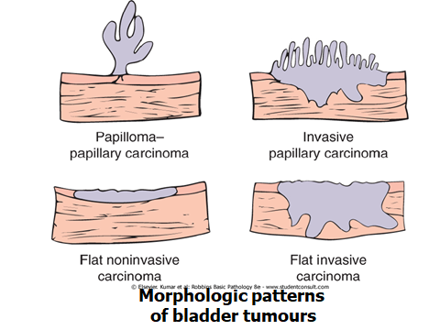

**BLADDER CARCINOMA**

ommon in males between 50-70 years.   
**Predisposing Factors (Precancerous Lesions):**(1) Cigarette smoking.   
(2) Villous (urothelial) papilloma.   
(3) Chemical carcinogens as aniline dyes (alpha and beta naphylamine).   
(4) Chronic irritation by chronic cystitis and urinary stones.   
**Site:** Most cases affect lateral walls, posterior wall and trigone.   
**Gross Picture:**(1) ***Papillary carcinoma:*** Common and may be single or multiple tumour.   
 (a) Low malignant and early papillary carcinomas appear as branching, thin,   
 delicate, villous-like pink projections with a long narrow pedicle.   
 (b) More malignant tumours appear as soft cauliflower-like papillary growth.   
 The villi are broad and short and the tumour is indurated.   
(2) ***Non-papillary carcinoma:*** Less common and appears as a hard nodular   
 infiltrating mass with little projection into the lumen. Mucosal ulceration may   
 occur.

**Microscopic Picture:**(1) Papillary tumours are ***urothelial carcinoma***. The anaplasia in the tumour   
 cells may be slight (grade I), moderate (grade II) or marked (grade III).   
(2) Non-papillary carcinomas are ***urothelial cell carcinoma,*** less commonly  ***squamous cell carcinoma*** and rarely ***adenocarcinonw.***

**Spread:**(1) ***Local spread:*** To the ureters, prostate, seminal vesicle, uterus, and rectum.   
 Local spread may **→** a malignant fistula between the bladder and the vagina,   
 colon or rectum.   
(2) ***Lymphatic spread:*** To the hypogastric and iliac lymph nodes.   
(3) ***Blood spread:*** To the lungs, liver and bones specially the lumber vertebrae and   
 pelvic bones.   
**Complications:** Marked haematuria, hydroureter, hydronephrosis, pyelonephritis and   
malignant fistulas. Complications are the common cause of death.

* Haematuria

- Causes:

-Types:

* Proteinuria:

- Definition

- Types

- causes

* Albuminuria/ selective proteinuria
* Pyuria

- Definition

- Causes