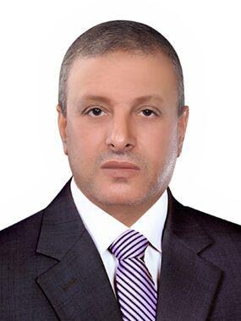
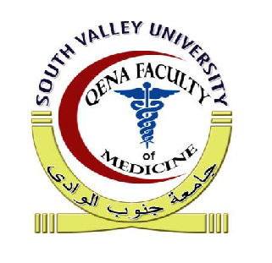

Personal information:
- Name and nationality : hassan mohammed Ibrahim Ali, Egyptian .
- Title/Rank: Assistant Professor of Dermatology,Venereology and Andrology,MD degree.
- Tel:00201011524245
- Date and place of birth :19/7/2019 ,Qena ,Qus.
- Work Address: Dermatology, Venereology and Andrology Department,Qena Faculty of Medicine, South Valley University, Qena, Egypt.
- Specialization: Dermatology, Venereology and Andrology Department.
- Current Home Address:Qena.
- Marital status : married.
- Disabilities and chronic illness: None.
- Languages: Arabic/English :Excellent reading ,Writing and conservation .
- Personal E.mail address:
alhagazy1971@yahoo.com.
- Institutional E.mail address:
Hassan.mohmed @med.svu.edu.eg.
- My google scholar page URL:
- https://scholar.google.com.eg/citation ,user=u2EXPHgAAAA)&hl=en.
- ORCID ID:orcid . 0000-0002-7788-3302
- Research gate score:15.7
- Scopus Author :56393884000
- Pubmed link of my published articles:http://www.ncbi.nlm.gov/pumbed/ term=Hassan+M+Ibrahim.
Qualifications
- Bachelor of Medicine and surgery ,faculty of medicine, Assuit university, Assuit, Egypt, septemer1995.
- M.SC. of dermatology, venereology, andrology, December 2005, sohag medical college, south valley university.
- M.D degree of dermatology, venereology and Andrology ,24/7/2014.
- Director of Qena University Hospital, South valley University at 28/1/2015.
- Assistant professor of Dermatology, Venereology and Andrology at 28/7/2019.
- Head of Department of Dermatology, Venereology and Andrology at 28/8/2019

National and International Publishing
1- Platelets rich plasma versus minoxidil 5% in treatment ofalopecia areata: A trichoscopic evaluation
- Moustafa A. El Taieb, Hassan Ibrahim, Essam A. Nada, Mai Seif Al Din.
- Dermatologic Therapy, 2016, 1-6....Impact Factor 1.56
2- Efficacy of medical treatment in varicocele patients presenting with Oligoasthenoteratozoospermia
- Hassan M. Ibrahim, Moustafa A. El Taieb, Essam A. Nada, Huda A Al Samea, and Mahmoud Aly
- Al-AzharAssiut Medical Journal, July 2015, Indexed Score 5

3-Vitamin D levels in acne vulgaris patients treated with oralisotretinoin

- Mohammed Abu El-Hamd MD1 | Moustafa A El Taieb MD2 | Hassan M IbrahimMD3 | Sanaa S Aly MD4
- Journal of Cosmetic Dermatology, Accepted in 15/1/2018,
Impact Factor 1.56
4-Effect of narrow-band ultraviolet B on the serum of25-hydroxyvitamin D in vitiligo patients
- Hassan Ibrahim MD1 | Moustafa El Taieb MD2 | Zeinab El Gamel MSc3 |Abdel Rahman El Saied MD4
- Journal of Cosmetic Dermatology, Accepted 12/1/2018, Impact Factor 1.56
5- 25-Hydroxy cholecalciferol, anti-Müllerianhormone, and thyroid profiles among infertilemen
- Mohammed H. Hassan, Hassan M. Ibrahim &Moustafa A. El-Taieb
The Aging male, published 12/11/2018 ....Impact Factor 2.5
6- Seminal and serum leptin levels in male patients with varicocele and isolated asthenozoospermia before and after repair
- Moustafa A. El Taieb, Eisa M Hegazy, Hassan M Ibrahim & Ahmed K Ibrahim
- The Aging Male, published 3/1/2019......Impact Factor 2.5
7- Serum interleukin-6 and interferon-γ in patients with leprosy
- Essam Nada, Moustafa El Taieb, Hanan Fayed, Hasan Ibrahim, YasminYasin
- Egyptian Journal of Dermatology and Venereology, 6/2/2018,
Indexed Score: 5
8- Dermoscopy versus skin biopsy in diagnosis of suspicious skin lesions
- Hassan Ibrahim, Moustafa El-Taieb, Ahmed Ahmed, Radia Hamada,
Essam Nada
- Al-AzharAssiut Medical Journal, Accepted 28 March 2018,
Indexed Score 5
9- Efficacy of sildenafil citrate in the treatment of female sexual dysfunction
- Essam El-din Nada 1, Moustafa El Taieb2, Hassan Ibrahim, El Shimaa Ibrahim .
- Human Andrology, Acceted 30 July, 2018, Indexed Score: 7
- Posters in European academy of Dermatology and Venereology Congress:
1- Efficacy of dermoscopy versus skin biopsy in diagnosis of suspicious skin lesions 2015
- Moustafa A El Taieb1, Ahmed RH Ahmed2, Hassan M. Ibrahim3, Radia Hamada4, Essam Nada5
2- Predictive Value of Serum Interleukin 6 and Interferon-γ in Leprosy Patients 2016
- Moustafa El Taieb, Hanan Fayed, Hassan Ibrahim , YasminYasin, Essam Nada

Training courses -
- Acourse for developing faculty and leadership capacity at South Valley University.
- The preparation of the university teacher at South Valley University
- Laser course of the National Institute of Laser Sciences - Cairo University
- ICDL Certificate - ICTC Training Course
- Certificate of English Proficiency (Toefel) EinShamas University
- Certificate of Mastery of German Language University of South Valley
- Participating in many scientific conferences supervised by dermatologists, Venereologist and Andrologist doctors, including the first scientific conference of the dermatology, Venereology and Andrology of the Faculty of Medicine Qena and Aswan.
- Participation in the EuropeanAcadem of Dermatology and Venereology Conference No. 24 in Copenhagen, Denmark 2015 and No. 25 in Vienna - Austria 2016.
- Speaker in 28 Congress of the Egyptian Society of Andrology 14-15 December 2017.
- Speaker in Asian World Dermatology(Dubai Derma,19-21 March 2018).
- Speaker in in 29 Congress of the Egyptian Society of Andrology (24th &25th January 2019, Grand Nile Tower, Cairo, Egypt.

