
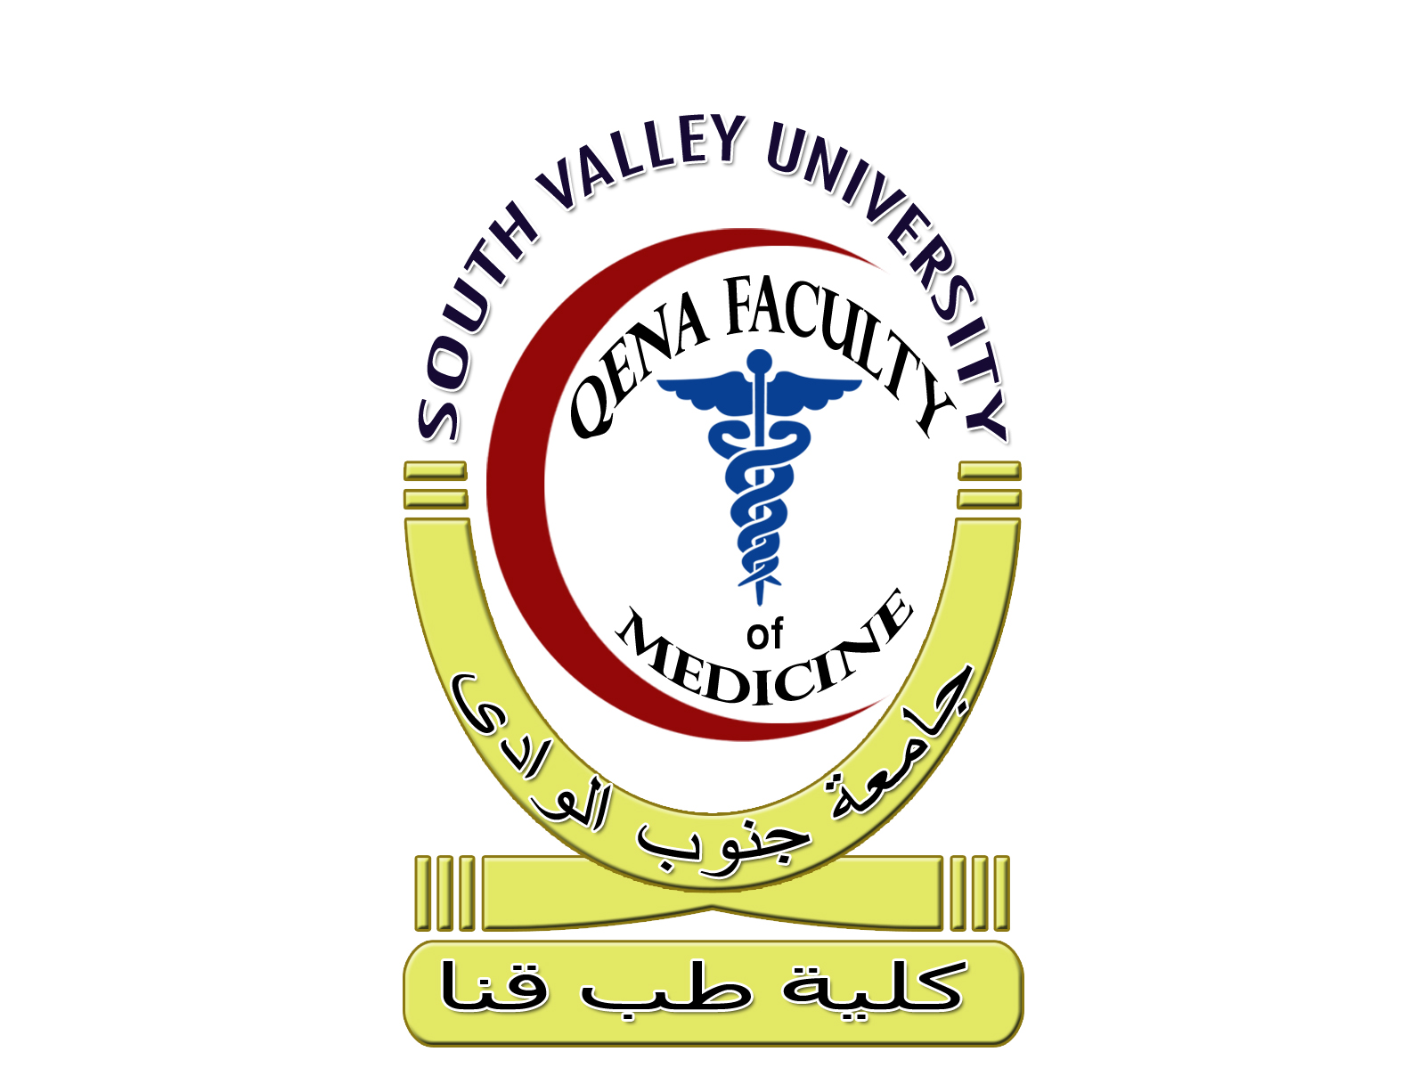
South Valley University Date: 13\8\2018
Qena Faculty Of Medicine Time allowed: 2 Hours Department Of Biochemistry
First year final term medical biochemistry exam
Biochemistry-II

- Answer all the following questions and illustrate your answer with the chemical structures whenever possible.

- On biochemical basis explain: (6 marks each)

- Isoenzymes of medical importance.
- One fat soluble and one water soluble vitamin that are important for skin health and integrity.
- Heterocyclic amino acids.
- Normal hemoglobin chemistry.
- Alkali reserve.

- Describe the structure of the immunoglobulin monomer (2 marks).

Good luck
Name of the examiners:
Prof. Tahia Hashim Saleem
Dr. Mohammed Hosny Hassan
---------------------------------------------------------------------------------- سوف ينعقد الامتحان الشفوي والعملي لمادة الكيمياء الحيوية الطبية يوم الاثنين الموافق13\8\2018 لجميع الطلاب بالقسم عقب الامتحان النظري مباشرة

South Valley University Date: 27\8\2017
Qena Faculty Of Medicine Time allowed: 2 Hours Department Of Biochemistry
First year Final Term Medical Biochemistry-I Exam

- Answer all the following questions and illustrate your answer with the chemical structures whenever possible.

Part I: Write down the structural formulae of: (2 marks each)

- Two sugar alcohols
- Two choline containing lipids.
- Chondroitin Sulfate A.
- Two essential fatty acids.
Part II: On biochemical basis explain in details: (5 marks each)
- Initiation step of protein synthesis.
- Antioxidants.
- Telomeres.
- Glycolipids.

Part IV: Discuss Different types of disaccharides (4 marks)

Good luck
Name of the examiners:
Prof.Dr:Tahia Hashim Saleem
Dr. Mohammed H. Hassan
----------------------------------------------------------------------------------
سوف ينعقد الامتحان العملي و الشفوى بمشيئة اللة تعالى لمادة الكيمياء الحيوية الطبية يوم الثلاثاء الموافق 29/8/2017 لجميع الطلاب بالقسم بدءا من الساعة الثامنه صباحا
South Valley University Date: 29\8\2017
Qena Faculty Of Medicine Time allowed: 2 Hours Department Of Biochemistry
First year Final Term Biochemistry-II Exam

- Answer all the following questions and illustrate your answer with the chemical structures whenever possible.

Part I: Write down the structural formulae of: (2 marks each)

- Glutathione.
- Heme molecule.
- 1,25 dihydroxycholecalciferol.
- Two essential amino acids.
Part II: On biochemical basis explain in details: (5 marks each)
- Bonds responsible for protein structure.
- Vitamin A.
- Types of abnormal hemoglobin.
- Factors affecting the rate of enzyme catalyzed reactions.

Part IV: Discuss scleroproteins (4 marks)

Good luck
Name of the examiners:
Prof.Dr:Tahia Hashim Saleem
Dr. Mohammed H. Hassan
----------------------------------------------------------------------------------
سوف ينعقد الامتحان العملي و الشفوى بمشيئة اللة تعالى لمادة الكيمياء الحيوية الطبية عقب الامتحان النظري مباشرة لجميع الطلاب بالقسم
South Valley University Date: 6\8\2018
Qena Faculty Of Medicine Time allowed: 2 Hours Department Of Biochemistry
Second year final term medical biochemistry exam
Metabolism-I

- Answer all the following questions and illustrate your answer with the chemical structures whenever possible.

- On biochemical basis explain: (6 marks each)

- Regulation of blood glucose level.
- Iron metabolism.
- Urine analysis.
- CyP450 reaction cycle involved in xenobiotic metabolism.
- Ketogenesis.

- Enumerates the uncouplers of oxidative phosphorylation (2 marks).

Good luck
Name of the examiners:
Prof. Tahia Hashim Saleem
Dr. Mohammed Hosny Hassan
---------------------------------------------------------------------------------- سوف ينعقد الامتحان الشفوي والعملي لمادة الكيمياء الحيوية الطبية يوم الاثنين الموافق6\8\2018 لجميع الطلاب بالقسم عقب الامتحان النظري مباشرة

South Valley University Date: 20 \8\2017
Qena Faculty Of Medicine Time allowed: 2 Hours Department Of Biochemistry
Second Year Final Term Metabolism-I Exam

- Answer all the following questions and illustrate your answer with the chemical structures whenever possible.

Part I: On biochemical basis explain: (4 marks each)
- CyP450 reaction cycle.
- Calcium homeostasis.
- Composition of milk.
- L-Carnitine.

Part II: Discuss each of the followings: (8 marks each)
- Gluconeogenic pathways.
- Cholesterol metabolism.

Good luck
Name of the examiners:
Prof.Dr:Tahia Hashim Saleem
Dr. Mohammed H. Hassan
----------------------------------------------------------------------------------

سوف ينعقد الامتحان العملي بمشيئة اللة تعالى لمادة الكيمياء الحيوية الطبية عقب الامتحان النظري مباشرة لجميع الطلاب بالقسم
سوف ينعقد الامتحان الشفوى بمشيئة اللة تعالى لمادة الكيمياء الحيوية الطبية يوم الثلاثاء الموافق 29/8/2017 لجميع الطلاب بالقسم بدءا من الساعة الثامنه صباحا
South Valley University Date: 6\8\2018
Qena Faculty Of Medicine Time allowed: 2 Hours Department Of Biochemistry
Second year final term medical biochemistry exam
Metabolism-II

- Answer all the following questions and illustrate your answer with the chemical structures whenever possible.

- On biochemical basis explain: (6 marks each)

- Role of liver in starvation.
- Metabolism of tryptophan amino acid.
- Hormones of the adrenal cortex, and discuss the mechanism of action and metabolic effects of one of them.
- Hemoglobin synthesis.
- Catabolism of purines.

- Enumerates indices used for measurement of obesity (2 marks).

Good luck
Name of the examiners:
Prof. Tahia Hashim Saleem
Dr. Mohammed Hosny Hassan
---------------------------------------------------------------------------------- سوف ينعقد الامتحان الشفوي والعملي لمادة الكيمياء الحيوية الطبية يوم الاثنين الموافق6\8\2018 لجميع الطلاب بالقسم عقب الامتحان النظري مباشرة

South Valley University Date: 13\8\2018
Qena Faculty Of Medicine Time allowed: 2 Hours Department Of Biochemistry
First year final term medical biochemistry exam
Biochemistry-II

- Answer all the following questions and illustrate your answer with the chemical structures whenever possible.

- On biochemical basis explain: (6 marks each)

- Isoenzymes of medical importance.
- One fat soluble and one water soluble vitamin that are important for skin health and integrity.
- Heterocyclic amino acids.
- Normal hemoglobin chemistry.
- Alkali reserve.

- Describe the structure of the immunoglobulin monomer (2 marks).

Good luck
Name of the examiners:
Prof. Tahia Hashim Saleem
Dr. Mohammed Hosny Hassan
---------------------------------------------------------------------------------- سوف ينعقد الامتحان الشفوي والعملي لمادة الكيمياء الحيوية الطبية يوم الاثنين الموافق13\8\2018 لجميع الطلاب بالقسم عقب الامتحان النظري مباشرة

South Valley University Date: 27\8\2017
Qena Faculty Of Medicine Time allowed: 2 Hours Department Of Biochemistry
First year Final Term Medical Biochemistry-I Exam

- Answer all the following questions and illustrate your answer with the chemical structures whenever possible.

Part I: Write down the structural formulae of: (2 marks each)

- Two sugar alcohols
- Two choline containing lipids.
- Chondroitin Sulfate A.
- Two essential fatty acids.
Part II: On biochemical basis explain in details: (5 marks each)
- Initiation step of protein synthesis.
- Antioxidants.
- Telomeres.
- Glycolipids.

Part IV: Discuss Different types of disaccharides (4 marks)

Good luck
Name of the examiners:
Prof.Dr:Tahia Hashim Saleem
Dr. Mohammed H. Hassan
----------------------------------------------------------------------------------
South Valley University Date: 29\8\2017
Qena Faculty Of Medicine Time allowed: 2 Hours Department Of Biochemistry
First year Final Term Biochemistry-II Exam

- Answer all the following questions and illustrate your answer with the chemical structures whenever possible.

Part I: Write down the structural formulae of: (2 marks each)

- Glutathione.
- Heme molecule.
- 1,25 dihydroxycholecalciferol.
- Two essential amino acids.
Part II: On biochemical basis explain in details: (5 marks each)
- Bonds responsible for protein structure.
- Vitamin A.
- Types of abnormal hemoglobin.
- Factors affecting the rate of enzyme catalyzed reactions.

Part IV: Discuss scleroproteins (4 marks)

Good luck
Name of the examiners:
Prof.Dr:Tahia Hashim Saleem
Dr. Mohammed H. Hassan
----------------------------------------------------------------------------------
South Valley University Date: 6\8\2018
Qena Faculty Of Medicine Time allowed: 2 Hours Department Of Biochemistry
Second year final term medical biochemistry exam
Metabolism-I

- Answer all the following questions and illustrate your answer with the chemical structures whenever possible.

- On biochemical basis explain: (6 marks each)

- Regulation of blood glucose level.
- Iron metabolism.
- Urine analysis.
- CyP450 reaction cycle involved in xenobiotic metabolism.
- Ketogenesis.

- Enumerates the uncouplers of oxidative phosphorylation (2 marks).

Good luck
Name of the examiners:
Prof. Tahia Hashim Saleem
Dr. Mohammed Hosny Hassan
---------------------------------------------------------------------------------- سوف ينعقد الامتحان الشفوي والعملي لمادة الكيمياء الحيوية الطبية يوم الاثنين الموافق6\8\2018 لجميع الطلاب بالقسم عقب الامتحان النظري مباشرة

South Valley University Date: 20 \8\2017
Qena Faculty Of Medicine Time allowed: 2 Hours Department Of Biochemistry
Second Year Final Term Metabolism-I Exam

- Answer all the following questions and illustrate your answer with the chemical structures whenever possible.

Part I: On biochemical basis explain: (4 marks each)
- CyP450 reaction cycle.
- Calcium homeostasis.
- Composition of milk.
- L-Carnitine.

Part II: Discuss each of the followings: (8 marks each)
- Gluconeogenic pathways.
- Cholesterol metabolism.

Good luck
Name of the examiners:
Prof.Dr:Tahia Hashim Saleem
Dr. Mohammed H. Hassan
----------------------------------------------------------------------------------

South Valley University Date: 6\8\2018
Qena Faculty Of Medicine Time allowed: 2 Hours Department Of Biochemistry
Second year final term medical biochemistry exam
Metabolism-II

- Answer all the following questions and illustrate your answer with the chemical structures whenever possible.

- On biochemical basis explain: (6 marks each)

- Role of liver in starvation.
- Metabolism of tryptophan amino acid.
- Hormones of the adrenal cortex, and discuss the mechanism of action and metabolic effects of one of them.
- Hemoglobin synthesis.
- Catabolism of purines.

- Enumerates indices used for measurement of obesity (2 marks).

Good luck
Name of the examiners:
Prof. Tahia Hashim Saleem
Dr. Mohammed Hosny Hassan
---------------------------------------------------------------------------------- سوف ينعقد الامتحان الشفوي والعملي لمادة الكيمياء الحيوية الطبية يوم الاثنين الموافق6\8\2018 لجميع الطلاب بالقسم عقب الامتحان النظري مباشرة

South Valley University Date: 29 \8\2017
Qena Faculty Of Medicine Time allowed: 2 Hours Department Of Biochemistry
Second Year Final Term Metabolism-II Exam

- Answer all the following questions and illustrate your answer with the chemical structures whenever possible.

Part I: On biochemical basis explain: (4 marks each)
- Fates of ammonia.
- Uric acid synthesis.
- Heme synthesis.
- Transmethylation reactions.

Part II: Discuss each of the followings: (8 marks each)
- Thyroid hormones.
- Role of liver in starvation.

Good luck
Name of the examiners:
Prof.Dr:Tahia Hashim Saleem

Dr. Mohammed H. Hassan

South Valley University Date: 29 \8\2017
Qena Faculty Of Medicine Time allowed: 2 Hours Department Of Biochemistry
Second Year Final Term Metabolism-II Exam

- Answer all the following questions and illustrate your answer with the chemical structures whenever possible.

Part I: On biochemical basis explain: (4 marks each)
- Fates of ammonia.
- Uric acid synthesis.
- Heme synthesis.
- Transmethylation reactions.

Part II: Discuss each of the followings: (8 marks each)
- Thyroid hormones.
- Role of liver in starvation.

Good luck
Name of the examiners:
Prof.Dr:Tahia Hashim Saleem
Dr. Mohammed H. Hassan
----------------------------------------------------------------------------------

سوف ينعقد الامتحان العملي و الشفوى بمشيئة اللة تعالى لمادة الكيمياء الحيوية الطبية عقب الامتحان النظري مباشرة لجميع الطلاب بالقسم

